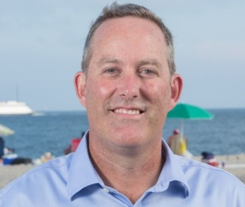
Adam W. Whelchel, Ph.D.
Director of Science
The Nature Conservancy/CT
awhelchel@tnc.org
(860) 970-8442
www.adamwhelchel.com

Short Biography:

Dr. Adam Whelchel’s twenty-seven-year career in leadership positions has catalyzed partnerships with strategic direction while with government agencies, private firms, academic institutions, and non-profits in the United States, China, Europe, Southeast Asia, Caribbean, and Africa. Adam Whelchel is an author, facilitator, and dynamic communicator called upon to assist diverse groups from around the world with team building, strategic planning, and community building. Recently, Adam served as the key facilitator on the Puerto Rico Climate Adaptation Plan and as a Lead Author for the third U.S. National Climate Assessment. In addition, Adam is the founder of Community Resilience Building which has helped over 325 municipalities and academic institutions across 7 states, to date.

